**PRACTICAL 1**

**COMPUTER ORGANISATION AND ARCHITECTURE**

|  |  |
| --- | --- |
| **NAME: VARUN KHADAYATE** | **ROLL NO: A016** |
| **PROGRAM: BTECH SY** | **DIVISION: CSBS** |
| **BATCH: 1** | **DATE OF EXPERIMENT: 22/07/2020** |

**EXPERIMENT 1a**

**To Recognize Various Components of a Personal Computer**

Computers come in all types and sizes. These are primarily two main sizes of computers. They are:

* Portable
* Desktop

The portable computer comes in various sizes and is referred to as laptops, notebooks, and hand-held computers. These generally not differentiate, the laptop being the largest and the hand-held is the smallest size. These documents will mainly talks about the desktop computer although portable computer issues are also discussed in various areas.

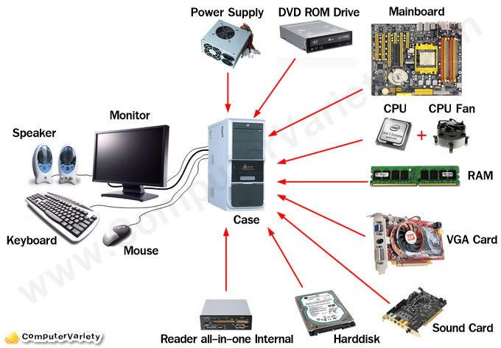

**Computer Components:**

Computers are made of the following basic components:

1. **Hardware inside:**
   1. **Power Supply-** The power supply comes with the case, but this component is mentioned separately since there are various types of power supplies. The one you should get depends on the requirements of your system. This will be discussed in more detail later.
   2. **Motherboard-** This s where the core components of your computer reside which are listed below. Also the support cards for video, sound, networking and more are mounted in this board.
      1. **Microprocessor-** This is the brain of your computer. It performs commands and instructions and controls the operation of the computer. 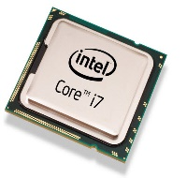
      2. **Memory-** the RAM in your system is mounted on the motherboard. This is memory that must be powered on to retain its contents.
      3. **Drive controllers-** The drive controller control the interface of your system to your hard drives. The controllers your hard drives work by controlling their operation on most systems, they are included on the motherboard. However you may add additional controllers for faster or other types of drives
   3. **Hard disk drives-** This is where your files are permanently stored on your computer. Also, normal, your operating system is installed here. 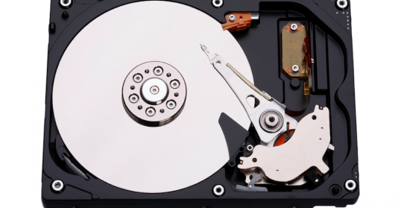
   4. **CD-ROM drive(s) -** This is normally read only drive where files are permanently stored. There are now read/write CD-ROM drives that use special software to allow users to read from and write to these drives.

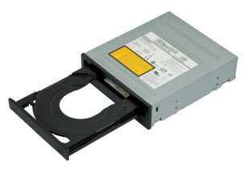

* 1. **Floppy drivers-** floppy is a small disk storage device that today typically has about 14 Megabytes of memory capacity.

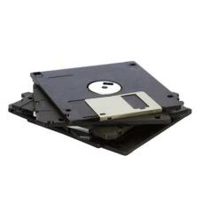

1. **Monitor-** This device which operates responding to their commands a TV set lets the user see how the computer is responding to their to their commands.

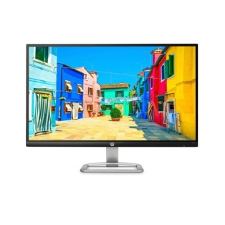

1. **Keyboard-** This is where the user enters text commands into the computer.

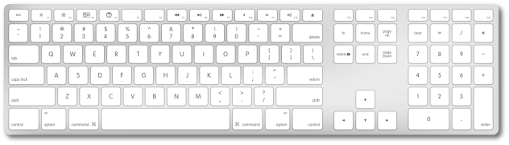

1. **Mouse-** A point and click interface for entering commands which one well in graphical environment.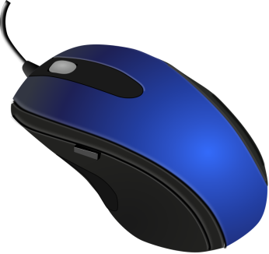

**EXPERIMENT 1b**

**Detailed study of Mother Board**

The primary component of a computer is the motherboard (sometimes called the “main board”). The motherboard is the hub which is used to connect all of the computer's essential components.

It is the central printed circuit board in many modem computers and holds many of crucial components of the system, providing connectors for other peripherals.

As is name suggests the motherboard acts as a parent board, which takes the form of a large printed circuit in connector for expansion cards, memory modules, the processor.

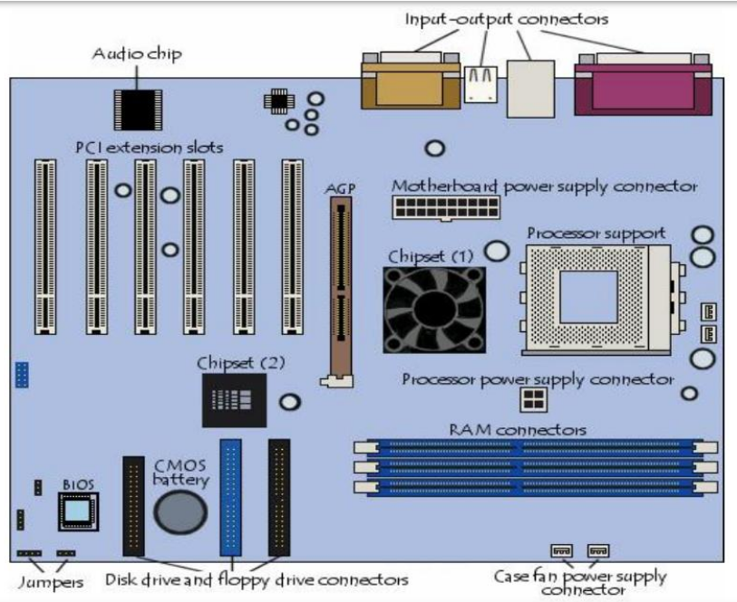

**Motherboard Contains:**

* Memory slot
* RAM
* Expansion slot CPU SOCKET
* Processor(CPU)
* Heat sink
* Processor fan
* SATA connectors
* North bridge chip
* Southbridge chip
* Rom BIOS
* CMOS Battery slot/CM OS Battery
* Capacitors
* I/0 controller
* Chipsets
* FDD header
* IDE Header
* AGP slot
* PCI slots

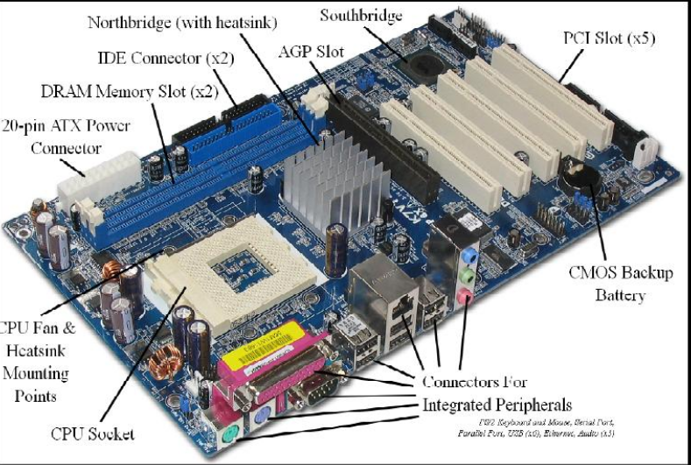

**Types of RAM slots:**

* **RIMM slots-** Rambus inline memory module

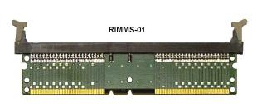

* **DIMM slots-** Dual in-line memory module. DIMM slots support also DDR1, 2, 3 RAM. Here data can be accessed on both sides.

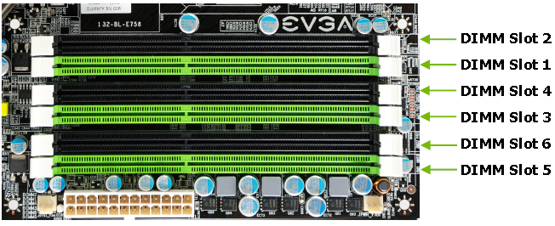

* **SIMM slots-** single in-line memory modules. Here data can be accessed in a single side.

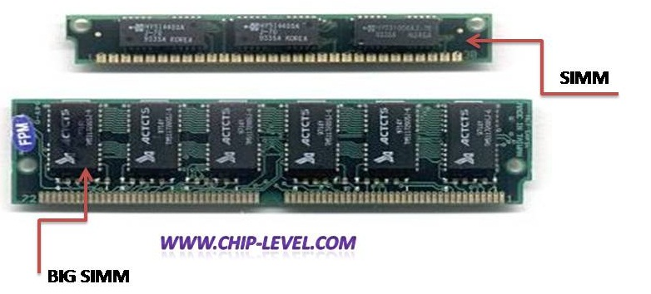

**RAM:** Is a volatile memory. It holds data temporarily.

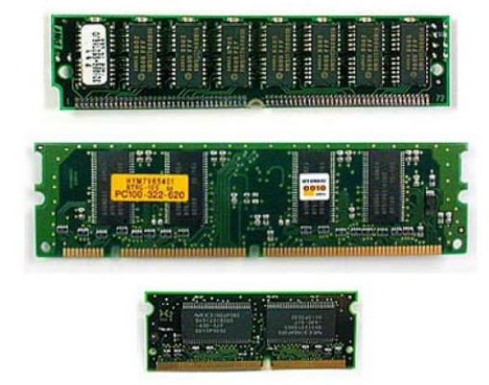

**Types of RAM:**

* SDR (Single data rate)
* DDR (Double data rate) 400MHZ
* DDR2(532 MHZ)
* DDR3(12000MHZ)

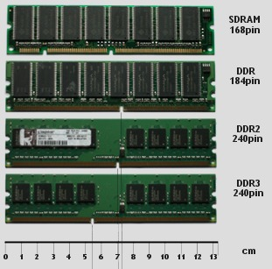

**Expansion slots:** These are the slots which contains the expansion cards. Through this more functionality is provided to the system. Various types of expansion slots are there

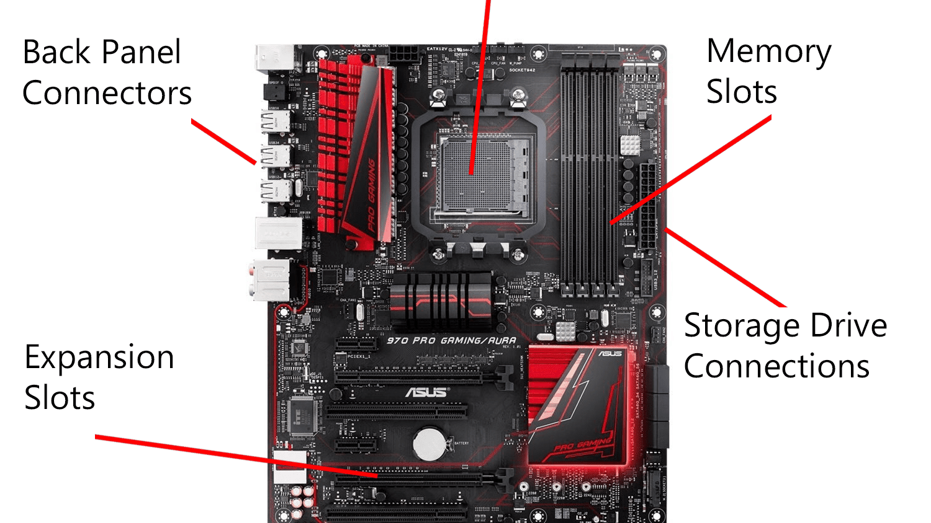

* **PCI slots:** It stands for Peripheral components Interconnect. We can insert network card and sound card in those sets

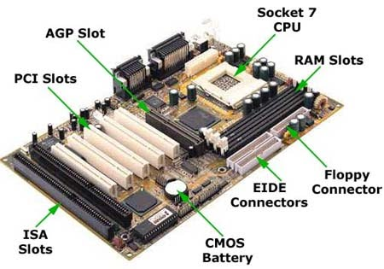

* **CPU socket:**  processor is mounted upon a socket called CPU Socket

**Processor:** a processor is the logic circuitry that responds to and processes the basic instructions that drive a computer.

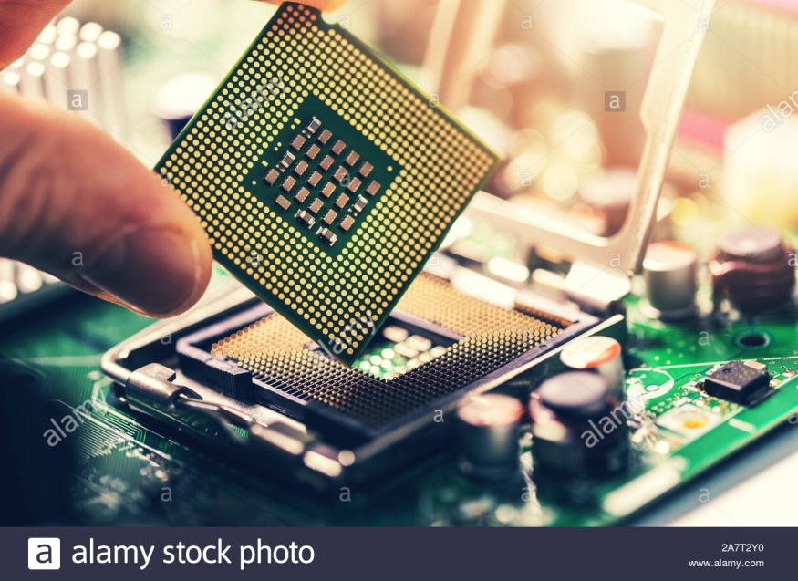

**Heat sink:** it absorbs heat from the processor. It is placed upon the processor.

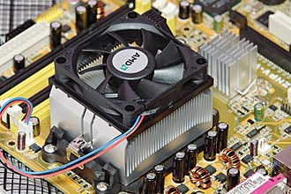

**Processor fan:** it is a cooling fan which cools the heat sink.

**IDE (Integrated Drive Electronics):** also known as ATA or PATA (renamed Parallel ATA, to differentiate from Serial ATA or SATA) is used with IBM compatible hard drives. IDE and its successor, Enhanced IDE (E IDE), are the commonly used with most Pentium computers.

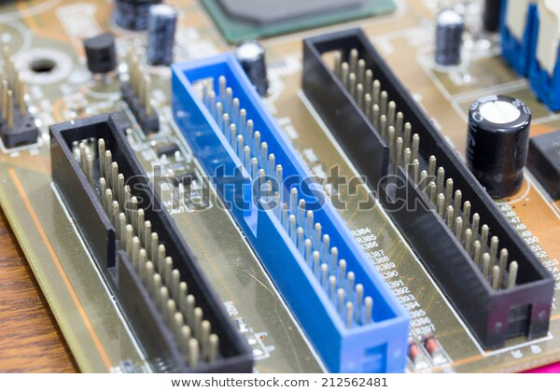

**SATA:** **Serial ATA** (**SATA or Serial Advanced Technology Attachment**) is a computer bus interface for connecting host bus adapters to mass storage devices such as hard disk drives and optical drives. Serial ATA was designed to replace the older parallel ATA (PATA)

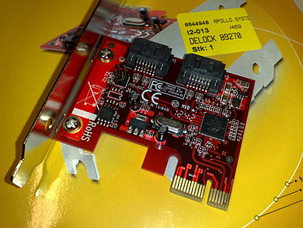

**Parallel ATA (PATA),** originally **AT Attachment** is an interface standard for the connection of storage devices such as hard disks, solid-state drives, floppy drives, and optical disc drives in computer

**North Bridge:** north-bridge is an Intel chipset that communicates with the computer processor and controls interaction with memory, the Peripheral Component Interconnect (PCI) bus, Level 2 cache, and all Accelerated Graphics Port (AGP) activities. North-bridge communicates with the processor using the front-side bus (FSB).

**South Bridge:** south-bridge is an Intel chipset that manages the basic forms of input/output(I/O) such as Universal Serial Bus(USB), serial, audio, Integrated Drive Electronics (IDE), and Industry Standard Architecture (ISA) I/O in a computer.

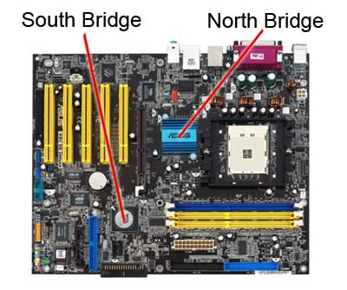

**ROM BIOS:**

BIOS are also known as PC firmware. ROM-BIOS is an abbreviation of Read Only Memory Bask Input\Output System. In PC's the BIOS contains all the code required to control the keyboard, display screen, disk drives, serial communications, and a number of miscellaneous functions.

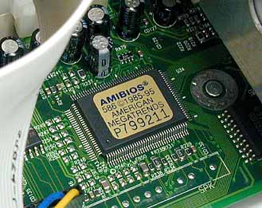

The BIOS is typically placed in a ROM chip that comes with the computer. This ensures that the BIOS will always be available and will not be damaged by disk failures. It also makes it possible for a computer to boot itself. Because RAM is faster than ROM, though, many computer manufacturers design systems so that the BIOS is copied from ROM to RAM each time the computer is booted. This is known as shadowing.

**CMOS BATTERY:**

All personal computers require a small battery on the system board that provides power to the Complementary Metal Oxide Semiconductor (CMOS) chip, even while the computer is turned off. This chip contains information about the system configuration (e.g., hard disk type, floppy drive types, date and time, and the order in which the computer will look for bootable disks). The CMOS battery allows the CMOS to preserve these settings.

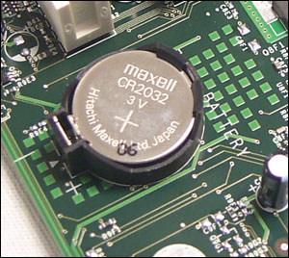

**Capacitors:**

A capacitor (originally known as condenser) is a passive two-terminal electrical component used to store energy in an electric field. Used to filter & smooth signals of motherboard.

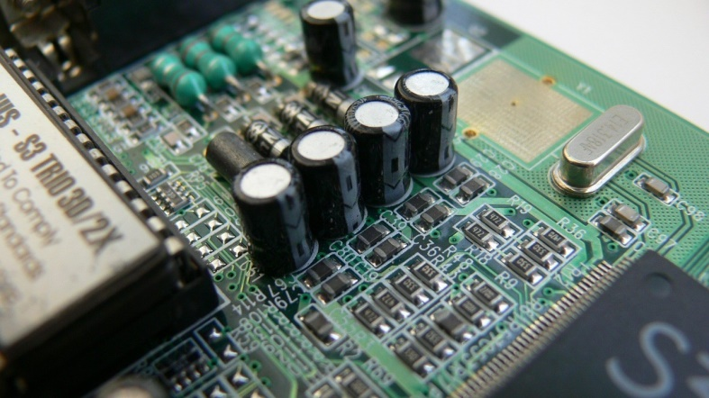

**l/O Controllers:** the Super I/O controller is a single chip that, much like the system chipset, performs many functions that used to take several pieces of hardware. Functions: Serial Port Control, Parallel Port Control, Floppy Disk Drive Control.

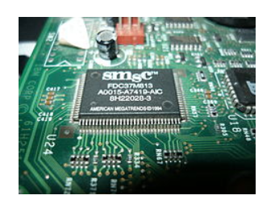

**Chipset:** the chipsets connects the microprocessor to the rest of motherboard.

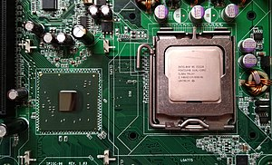

**Jumpers:** jumpers set CPU speed & resets the bios memory.

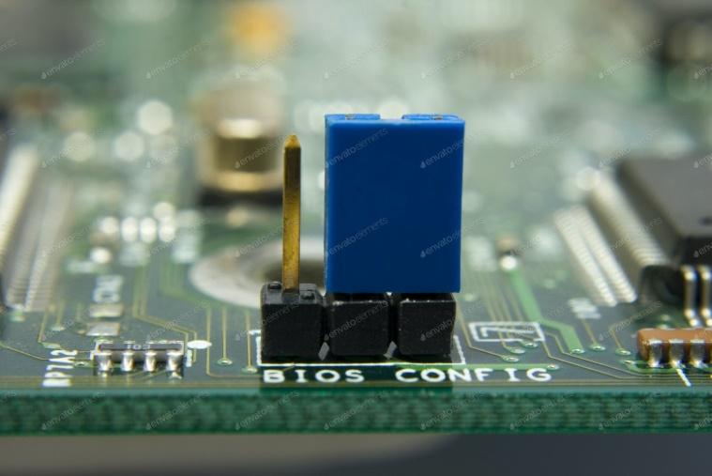

**IDE controller (header):** industry standards define two common types of hard drives: EIDE and SCSI. Majority of the PCs use EIDE drives. SCSI drives show up in high end PCs such as network servers or graphical workstations. The EIDE drive connects to the hard drive via a 2-inch-wide, 40-pin cable, which in turn connects to the motherboard. IDE controller is responsible for controlling the hard drive.

**Floppy controller (header):** the floppy drive connects to the computer via a 34-pin cable, which in turn connects to the motherboard. A floppy controller is one that is used to control the floppy drive.

**The input-output connectors:** the motherboard has a certain number of input/output sockets found on the rear panel.

**Most motherboards have the following connectors:**

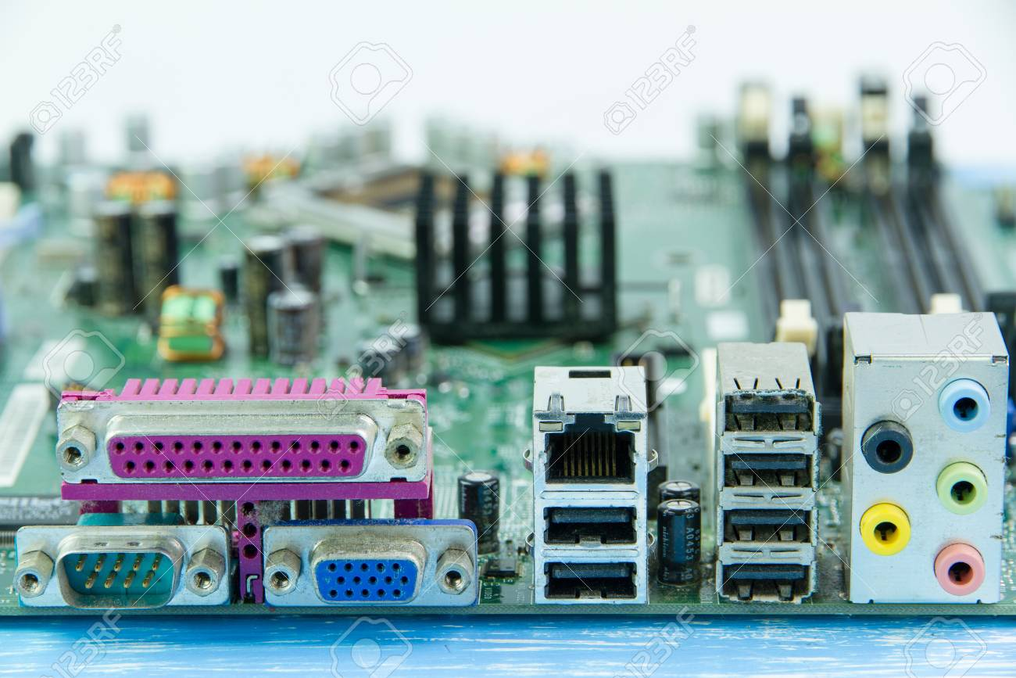

* A serial port, for connecting old peripherals;
* A parallel port, mainly for connecting old printers;
* USB ports (1.1, low-speed, or 2.0, high-speed), for connecting more recent peripherals.
* RJ 45 connector (called LAN or Ethernet port) used for connecting the computer to a network.
* It corresponds to a network card integrated into the motherboard.
* VGA connector (called SUB-D15), for connecting a monitor. This connector interfaces with the built-in graphics card.
* Audio plugs (Line-In, Line-Out and microphone), for connecting sound speaker system, as well as a microphone. This connector interfaces with the built-in sound card.
* Recent motherboards generally include a number of on board multimedia and networking.

**Devices which can be disabled:**

* 1. Integrated network card;
  2. Integrated graphics card;
  3. Integrated sound card;
  4. Upgraded hard drive controllers.